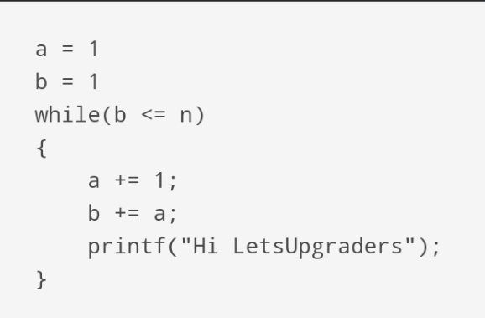
Day – 1 Assignment

Solution :-
while(b<=n) | Printf Statement Execute
1 | 1
2 | 2
3 | 3
.  .  .  n | .  .  .  n
So , the Time Complexity of this code is
T(n) = O(n)

